Fast**National University of Computer & Emerging Sciences, Karachi  
Fall-2017 CS-Department  
Midterm 1  
20th September 2017, 1:00 pm – 2pm**

|  |  |  |
| --- | --- | --- |
| **Course Code: CS203** | **Course Name: Database Systems** | |
| **Instructor Name / Names: Dr Zeeshan Ahmed, Mr. Ahsan Shah, Miss Tania Iram** | | |
| **Student Roll No:** | | **Section No:** |

Instructions :

* Return the question paper.
* Read each question completely before answering it. There are **3 questions and 3 pages** .
* In case of any ambiguity, you may make assumption. But your assumption should not contradict any statement in the question paper.
* This paper is subjective

**Time**: 60 minutes. **Max Marks**: 50 marks

Question 1: (10 marks)

1.  Given is a glimpse of a table in a legacy system for maintaining records of students and their advisers: /4

|  |  |  |  |
| --- | --- | --- | --- |
| Student name | Student_phone | Adviser Name | Adviser phone |
| Anna, Alvi | 232-9987 | Parks | 232-0098 |
| Rim, Simon | 232-9918 | Parks | 232-0098 |
| Sohaib, Alvi | 232-9987 | Johns | 232-0094 |
| Hayat, Khalid | 232-2289 | Johns | 232-0094 |

* Write any 3 problems that you find out in this design which make manipulating data difficult.
* Suggest the improvements to remove those flaws you found in the design.

1. Describe Data Independence in context of three schema architecture. /3
2. What is the difference between super key and key? What is default super key in a relation? /3

Question2: (5 marks)

Suppose that each of the following Update operations is applied directly to the database state shown on next page. Discuss all integrity constraints violated by each operation, if any, and the different ways of enforcing these constraints. (10)

1. Insert <‘Robert’, ‘F’, ‘Scott’, ‘943775543’, ‘1972-06-21’, ‘2365 Newcastle Rd,

Bellaire, TX’, M, 58000, ‘888665555’, 1> into EMPLOYEE.

1. Delete the EMPLOYEE tuple with Ssn = ‘987654321’.
2. Modify the Super_ssn attribute of the EMPLOYEE tuple with Ssn =

‘999887777’ to ‘943775543’

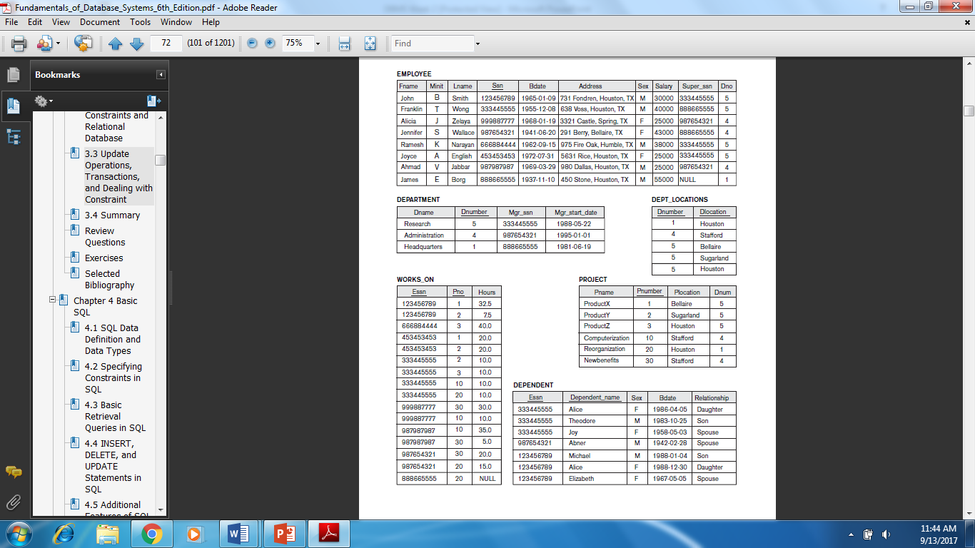

Question 3: _____________(25 marks)

Consider a STATE_AGENT database in which state agent deals with different buyers for property business. The houses own by different owners are sold out by agent on commission basis. Draw an ER diagram to model this application. Assume anything which you think is missing.

The data requirements are summarized as follows:

* Each house is uniquely identified by house identifier. A house has following non key attributes street address, city, state, a number of bedrooms and a number of bathrooms and an associated owner.
* Each owner has a Social Security Number, first name, last name, phone, and profession.
* An owner can have one or more houses.
* Agents represent owners in the sale of a house. An agent can list many houses, but only one agent can list a house.
* An agent has a unique agent number, name, phone number and an associated office.
* When an owner agrees to list a houses with an agent, a commission and a selling price are determined.
* An office has office identifier, phone number, the manager name, address and an optional agent number.
* Many agents can work at one office.
* A buyer has a Social Security Number, first name, last name, phone number, preferences for the number of bedrooms and bathrooms, and a price range.
* An agent can work with many buyers, but a buyer works with only one agent.

***BEST OF LUCK!***